Week 4 Assignment

1. Write a Python function to find the Max of three numbers.
2. Write a Python function to sum all the numbers in a list.
3. Write a Python function to multiply all the numbers in a list.
4. Write a Python program to reverse a string.
5. Write a Python function to calculate the factorial of a number (a non-negative integer). The function accepts the number as an argument.
6. Write a Python function to check whether a number is in a given range.
7. Write a Python function that accepts a string and calculate the number of upper case letters and lower case letters.
8. Write a Python function that takes a list and returns a new list with unique elements of the first list.
9. Write a Python function that takes a number as a parameter and check the number is prime or not.
10. Write a Python function that determines how many days are left to a birthday. The birthday should be taken as a parameter.
11. Write a Python function to check whether a number is perfect or not. (a perfect number is a positive integer that is equal to the sum of its proper positive divisors, that is, the sum of its positive divisors excluding the number itself).

Mini Project Work

Read about Tkinter module in Python and design a graphical calculator that can perform addition, subtraction, division, multiplication. It should have the following interface:

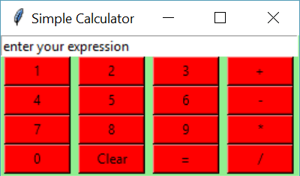

Note:

1. You may use colors of your choice. Fonts are optional.
2. Fork the following repository and upload your work to this repository.

<https://github.com/Lusimba/Little_Inventors_Assignments_Folder.git>